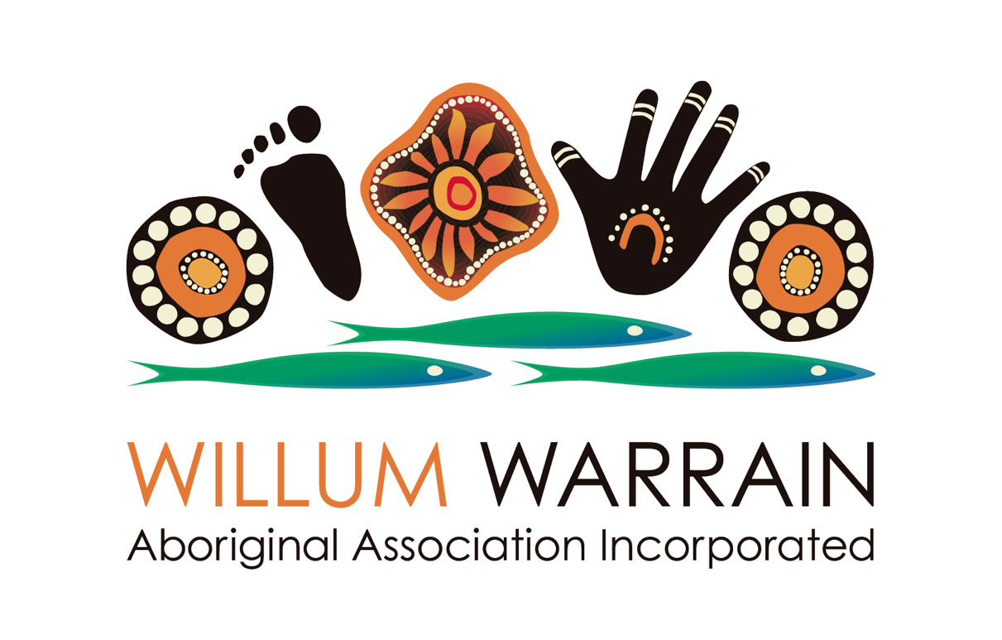
Aboriginal Family Services Coordinator

Willum Warrain is an Aboriginal Community-Controlled Organization located at Hastings on the Mornington Peninsula. It is a place of hope, healing and belonging for our mob down this way with a focus on cultural strengthening. The Gathering Place is located in a tranquil bush setting with a Koorie Bush Trail, ceremonial grounds and an adjoining wetlands area. We run a number of weekly culture-based programs targeting Aboriginal people as well as conducting weekend activities and celebrating significant Indigenous calendar events. It is also a destination for reconciliation for the broader Peninsula community and we have “open gate” policy inviting everyone to visit us.
The current Aboriginal membership of Willum Warrain is 290 adult members with a kinship reach of over 750.
The Aboriginal Family Services Coordinator will join a friendly and welcoming team of 7 current staff working hard to realise the aspirations of our Aboriginal community.
You will be supported by a committed and enthusiastic Board who are dedicated to seeing our community flourish in a culturally safe environment.

The role of the Aboriginal Family Services Coordinator will include:-

- Overseeing all programs and activities pertaining to Aboriginal families at our Gathering Place (especially Bush Play Group, the Aboriginal Women’s group and weekend cultural programs targeting girls, mothers and grandmothers)
- Creating an environment where our children are all grown up strong in culture
- Supporting cultural strengthening for all Aboriginal families in our community
- Organising annual culture-based camps targeting women and families
- Attending meetings and fostering stakeholder relationships on behalf of Willum Warrain related to children, youth and families (ie. IFVRAG, Mornington Peninsula Shire, headspace, VACCA, etc.)
- Liaising with the Orange Door safety hub and supporting Aboriginal women and families experiencing family violence
- Ensuring support is provided for Aboriginal families experiencing distress via our Community Support Fund
- Developing referral pathways for Aboriginal families in relation to education, health, housing, etc. and providing support for individual community members
- Advocacy on behalf of Aboriginal families, children and youth on the Mornington Peninsula
- Providing advice to the Board on behalf of our Aboriginal families to inform strategic planning and help identify resourcing needs
- Report to the Gathering Place Coordinator

Conditions:- Casual, 15-25 hours per week, hours negotiable. Family friendly working conditions, usually 9.30am-2.30pm Wednesday to Friday with some weekend events. School term-based - limited school holiday requirements apart from NAIDOC Week.

Salary is in accordance with Social, Community, Home Care and Disability Services Industry Award, 2010. Depending on experience and qualifications up to Level 3, pay point 2, Community Development Worker, Class 1, 3rd year – hourly rate, $36.51

Key criteria:-

Applicants will have experience working with Aboriginal families and community.

Applicants should have a community development or related qualification (Certificate 3 or above is desirable) and it is essential to have a Working With Children Check – Employee and a current police check.

Please apply by email to gpc@willumwarrain.com.au or contact the Gathering Place Coordinator on 0403 528 034 for further information

Applications are due in by 5.00pm, Friday 28th September, 2018
Interviews to take place Monday 1st October at Willum Warrain

