

Procedure number |  | Version | 3.1
Drafted by | Peter Aldenhoven  Taneisha Webster  Karsten Poll | Approved by Board on | NAME Aaron Simmler  Date 20/06/2024
Responsible person | Gathering Place Coordinator | Scheduled review date | 2026

Willum Warrain has a zero tolerance of child abuse and seeks at all times to provide a safe environment for all children who visit our Gathering Place and engage in our programs, activities and community events.

Willum Warrain Aboriginal Association is committed to child safety:-
- It has zero tolerance for child abuse
- It actively works to listen to and empower children
- It has systems to protect all children from abuse, and will take all allegations and concerns very seriously and responds to them consistently in line with the organisation’s policies and procedures
  - It is committed to promoting cultural safety for Aboriginal children, cultural safety for children from culturally and/or linguistically diverse backgrounds, and to providing a safe environment for children with a disability.

The Board of Willum Warrain has ultimate responsibility for the ongoing development of policies and procedures that will ensure the Gathering Place is a safe and protective environment for all children who visit or engage with our Association.
The Gathering Place Coordinator is responsible for oversighting the day-to-day operations of the Gathering Place and ensuring that all staff, volunteers and visitors to the Gathering Place are aware of Willum Warrain’s zero tolerance of child abuse and have been made aware of policies and processes for ensuring child safety at all times.
The Chief Executive Officer and Gathering Place Coordinator will be the designated Child Safety Officers* for the organisation.
Willum Warrain’s policies and processes regarding Child Safety will be prominently displayed at the Gathering Place for all visitors to access.
This includes being made aware of reporting processes should suspected abuse occur. See appendix 2.
Reports can be made to the Chief Executive Officer, Gathering Place Coordinator, Board members and all Willum Warrain employees and volunteers or directly to Victoria Police and Department of Health and Human Services.
Any reports of child abuse will be discussed immediately by the Internal Response Team made up of two Child Safety Officers- Chief Executive Officer, Executive Officer and Willum Warrain’s President.
Once a report has been received Willum Warrain’s Internal Response Team will:
• Ensure the immediate safety of the child or young person
• Offer support to the person who reports
• Initiate an investigation and determine what, if any, actions need to be taken
• If required report the concern to the police, child protection or the Commission for Children and Young People.
*Child safety officers are the people in the organisation who have knowledge of child safety issues and are a point of contact for others who have questions or concerns or want to report an allegation of child abuse.

Willum Warrain Board members, staff and volunteers will be required to undertake training to ensure the protection of children, risk management strategies an understanding of child abuse and Child Safe legislation, reporting obligations and process.
All Board members, employees, volunteers and outside providers working with children at Willum Warrain will be required to have a working with children check and to be made aware of Willum Warrain’s Child Safe policy and processes.
Willum Warrain is committed to cultural safety for Aboriginal children, children from culturally and/or linguistically diverse backgrounds, and to providing a safe environment for children with a disability.
The Victorian Child Safe Standards (the Standards) were introduced as part of the response to the 2013 Victorian Parliamentary Inquiry into the Handling of Child Abuse by Religious and other non‐Government Organisations (the Betrayal of Trust Inquiry). The Standards were introduced via amendment to the Child Safety and Wellbeing Act 2005 (Vic), and from January 2017, all Victorian organisations which provide services for children, including Gathering Places, were required to comply with the Standards. Under the Child Safety Act 2005, the Commission for Children and Young People holds regulatory powers to oversee and enforce organisations’ compliance and there can be legal and financial consequences for non-compliance.

The new set of Standards are as follows.
Standard 1 | Organisations establish a culturally safe environment in which the diverse and unique identities and experiences of Aboriginal children and young people are respected and valued.
Standard 2 | Child safety and wellbeing is embedded in organisational leadership, governance and culture.
Standard 3 | Children and young people are empowered about their rights, participate in decisions affecting them and are taken seriously.
Standard 4 | Families and communities are informed and involved in promoting child safety and wellbeing.
Standard 5 | Equity is upheld and diverse needs respected in policy and practice.
Standard 6 | People working with children and young people are suitable and supported to reflect child safety and wellbeing values in practice.
Standard 7 | Processes for complaints and concerns are child focused.
Standard 8 | Staff and volunteers are equipped with the knowledge, skills and awareness to keep children and young people safe through ongoing education and training.
Standard 9 | Physical and online environments promote safety and wellbeing while minimising the opportunity for children and young people to be harmed.
Standard 10 | Implementation of the Child Safe Standards is regularly reviewed and improved.
Standard 11 | Policies and procedures document how the organisation is safe for children and young people.

What is a child safe policy?
The child safe standards aim to protect children from abuse in organisations, including physical violence, sexual offences, serious emotional or psychological abuse and serious neglect. The child safe policy is an overarching document that provides an overview of key elements of Willum Warrain’s approach to child safety. It should:
- clearly state the organisation’s zero tolerance of child abuse
- detail the organisation's child safe processes and procedures, or link to existing documents that include child safety considerations - for example, its reporting procedures (including leadership responsibilities), how to respond to an allegation of child abuse, human resources and recruitment practices, and risk management strategy.

Our commitment to child safety
Willum Warrain is committed to child safety.
We want children to be safe, happy and empowered. We support and respect all children, as well as our staff and volunteers.
We are committed to the safety, participation and empowerment of all children.
We have zero tolerance of child abuse, and all allegations and safety concerns will be treated very seriously and consistently with our robust policies and procedures.
We have legal and moral obligations to contact authorities when we are worried about a child’s safety, which we follow rigorously.
Our organisation is committed to preventing child abuse and identifying risks early and removing and reducing these risks.
Our organisation has human resources and recruitment practices for all staff and volunteers.
Our organisation is committed to training and educating our staff on child abuse risks.
We support and respect all children, as well as our staff and volunteers. We are committed to the cultural safety of Aboriginal children, the cultural safety of children from a culturally and/or linguistically diverse backgrounds, and to providing a safe environment for children with a disability.
We have specific policies, procedures and training in place that support our board, leadership team, staff and volunteers to achieve these commitments.
If you believe a child is at immediate risk of abuse phone 000.

Our children
This policy is intended to empower children who are vital and active participants in our organisation. We involve them when making decisions, especially about matters that directly affect them. We listen to their views and respect what they have to say.
We promote diversity and tolerance in our organisation, and people from all walks of life and cultural backgrounds are welcome. In particular we:
- promote the cultural safety, participation and empowerment of Aboriginal children
- promote the cultural safety, participation and empowerment of children from culturally and/or linguistically diverse backgrounds
  - ensure that children with a disability are safe and can participate equally.
  - Pay particular attention to the safety of those who are unable to live at home.
  - Pay particular attention to the safety of those who are lesbian, gay, bisexual, transgender, intersex, queer/questioning, asexual children.

Our staff and volunteers
This policy guides our board, staff, interns and volunteers on how to behave with children in our organisation.
All of our board, staff and volunteers must agree to abide by our Child Safe code of conduct which specifies the standards of conduct required when working with children. The code of conduct is displayed throughout Willum Warrain and included in all inductions. All staff and volunteers, as well as children and their families, are given the opportunity to contribute to the development of the code of conduct.

Training and supervision
Training and education is important to ensure that everyone in our organisation understands that child safety is everyone’s responsibility.
Our organisational culture aims for all board, staff and volunteers (in addition to parents/carers and children) to feel confident and comfortable in discussing any allegations of child abuse or child safety concerns. We train our staff and volunteers to identify, assess, and minimise risks of child abuse and to detect potential signs of child abuse.
The training plan ensures board, staff and volunteers -
- can identify, assess and minimise risks of child abuse and detect potential signs of abuse
- understand how the Standards apply to their role
- feel comfortable to discuss any child safety risks or concerns
- know who to talk to and how to report child safety concerns
- are provided ongoing supervision and training to implement the Child Safety Framework
- are supported to maintain a culture of child safety.
Willum Warrain’s board, staff and volunteers induction includes the Child Safety Code of Conduct and Child Safe Policy. New employees and volunteers will be supervised regularly to ensure they understand our organisation’s commitment to child safety and that everyone has a role to play in protecting children from abuse, as well as checking that their behaviour towards children is safe and appropriate (please refer to this organisation’s code of conduct and child safety code of conduct to understand appropriate behaviour further). Any inappropriate behaviour will be reported through appropriate channels, including the Department of Health and Human Services and Victoria Police
We also support our staff and volunteers through ongoing supervision to: develop their skills to protect children from abuse; and promote the cultural safety of Aboriginal children, the cultural safety of children from linguistically and/or diverse backgrounds, lesbian, gay, bisexual, transgender, intersex, queer/questioning, asexual children. and the safety of children with a disability.

Reporting
Incidents reported will be escalated to the Chief Executive Officer or Gathering Place Coordinator for The Internal Response team to review. See Appendix 2 for Child Safe Reporting. The Complaints Report will be completed in conjunction with the reporting staff member and the appropriate action taken to remain confidential and private. The report captures -details of the incident, date lodged, action taken, date of resolution and reason for decision, complainant response and any further action and copies of all correspondence and other materials received. See Appendix 1.
If you believe a child is at immediate risk of abuse phone 000.
Guidance on the matter maybe requested from the Commission for Children and Young People (1300 78 29 78) or reported to Child Protection (1300 655 795) who will be informed if management have formed a reasonable belief that a child has suffered or is likely to suffer significant harm as a result of abuse or neglect and their parent has not or is unlikely to protect them from harm of that type.
Staff are required to raise any claims of community members being on the Sex Offender Register immediately with Willum Warrain’s President (president@willumwarrain.org.au), Chief Executive Officer or Gathering Place Coordinator. The Board will verify claims and manage the risk. If a claim is found to be true, the CEO will inform the member that they are banned and to no longer attend the Gathering Place to ensure safety for everyone.

Recruitment
We take all reasonable steps to employ skilled people to work with children. We develop selection criteria and advertisements which clearly demonstrate our commitment to child safety and an awareness of our social and legislative responsibilities. Our organisation understands that when recruiting staff and volunteers we have ethical as well as legislative obligations.
We actively encourage applications from Aboriginal peoples, people from culturally and/or linguistically diverse backgrounds and people with a disability.
All people engaged in child-related work, including volunteers, are required to hold a Working with Children Check and to provide evidence of this Check. Please see the Working with Children Check website <www.workingwithchildren.vic.gov.au> for further information
We carry out reference checks and police record checks to ensure that we are recruiting the right employees. Police record checks are used only for the purposes of recruitment. We do retain our own records (but not the actual criminal record) if an applicant’s criminal history affected our decision making process.
If during the recruitment process a person’s records indicate a criminal history then the person will be given the opportunity to provide further information and context.

Fair procedures for personnel
The safety and wellbeing of children is our primary concern. We are also fair and just to personnel. The decisions we make when recruiting, assessing incidents, and undertaking disciplinary action will always be thorough, transparent, and based on evidence.
We record all allegations of abuse and safety concerns using our complaints reporting form including investigation updates.
If an allegation of abuse or a safety concern is raised, we provide updates to children and families on progress and any actions we as an organisation take.

Privacy
All personal information considered or recorded will respect the privacy of the individuals involved, whether they be staff, volunteers, community, parents or children, unless there is a risk to someone’s safety. We have safeguards and practices in place to ensure any personal information is protected online, accessible by the Internal Response team only. Everyone is entitled to know how this information is recorded, what will be done with it, and who will have access to it.

Legislative responsibilities
Our organisation takes our legal responsibilities seriously, including:
- Failure to disclose: Reporting child sexual abuse is a community-wide responsibility. All adults in Victoria who have a reasonable belief that an adult has committed a sexual offence against a child under 16 have an obligation to report that information to the police.
- Failure to protect: People of authority in our organisation will commit an offence if they know of a substantial risk of child sexual abuse and have the power or responsibility to reduce or remove the risk, but negligently fail to do so.
  - Any personnel who are mandatory reporters must comply with their duties.
  - Grooming is a criminal offence that involves predatory behaviour designed to prepare a child for sexual abuse, including online communication. Many perpetrators purposefully create relationships with children, their families, and carers in order to establish the conditions necessary for them to abuse the child.

Risk management
In Victoria, organisations are required to protect children when a risk is identified (see information about failure to protect above). In addition to general occupational health and safety risks, we proactively manage risks of abuse to our children. Willum Warrain’s board, staff and volunteers are required to have Working With Children Checks.
We have risk management strategies in place to identify, assess, and take steps to proactively minimise child abuse risks, which include risks posed by physical environments (for example, any doors that can lock), and online environments (for example, no staff or volunteer is to have contact with a child in organisations on social media).

Regular review
This policy will be reviewed every two years and following significant incidents if they occur. We will ensure that families and children have the opportunity to contribute. Where possible we do our best to work with local Aboriginal communities, culturally and/or linguistically diverse communities and people with a disability.

Allegations, concerns and complaints
Our organisation takes all allegations seriously and has practices in place to investigate thoroughly and quickly. Our staff and volunteers are trained to raise appropriately with allegations.
We work to ensure all children, families, staff and volunteers know what to do and who to tell if they observe abuse or are a victim, and if they notice inappropriate behaviour.
We all have a responsibility to report an allegation of abuse if we have a reasonable belief that an incident took place (see information about failure to disclose above).
If an adult has a reasonable belief that an incident has occurred then they must report the incident. Factors contributing to reasonable belief may be:
- a child states they or someone they know has been abused (noting that sometimes the child may in fact be referring to themselves)
- behaviour consistent with that of an abuse victim is observed
- someone else has raised a suspicion of abuse but is unwilling to report it
- observing suspicious behaviour.

Associated Documents

The following policies, procedures and guidelines support the implementation of the Child Safety Policy
- Code of Conduct
- Child Safe Code of Conduct
- Child Safety Staff Reporting Process and Flowchart
- Recruitment Policy
- Complaints Policy

Definitions

Child or children | Any child or young person up to the age of 18 years.
Child Abuse | Any act committed against a child involving:  • a sexual offence  • grooming  • physical violence  • serious emotional or psychological harm  • serious neglect.
Failure to Disclose | As defined in the Crimes Act 1958 (Vic), a failure to act on the legal obligation upon all adults to report to Victoria Police where they form a reasonable belief that a sexual offence has been committed by an adult (18 years and over) against a child under the age of 16 (16 being the legal age of consent).
Failure to Protect | As defined in the Crimes Act 1958 (Vic), a person with power and authority who fails to protect a child from criminal sexual abuse, they know of the risk of abuse, and are able to reduce or remove the risk but fail to do so.
Grooming | As defined in the Crimes Act 1958 (Vic), the act of communication, including online communication, with a child under the age of 16 or their parents with the intent of committing child sexual abuse. This includes predatory conduct undertaken to prepare a child for sexual abuse at a later time with the groomer (aged 18 years old or over) or another adult.
LGBTIQA+ | Lesbian, gay, bisexual, transgender, intersex, queer, asexual and gender diverse people.
Reasonable Belief | A reasonable belief is a belief based on facts that would lead a reasonable person to think that reportable conduct may have occurred. A reasonable belief is more than
Reasonable Excuse | A ‘reasonable excuse’ for not reporting information about child sexual abuse to police may include a fear for your or another person’s safety or if you believe the information has already been reported to police. If you are charged with the failure to disclose offence, a court may consider whether it was reasonable for you not to report in the circumstances.
Willum Warrain Associates | Board members, employees, volunteers and trainees.

Appendix 1 -Reporting

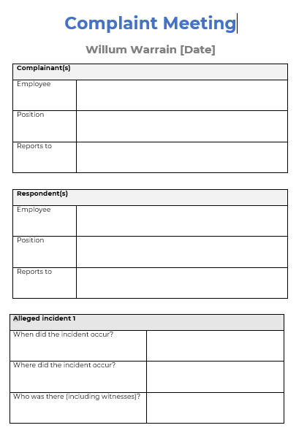 | 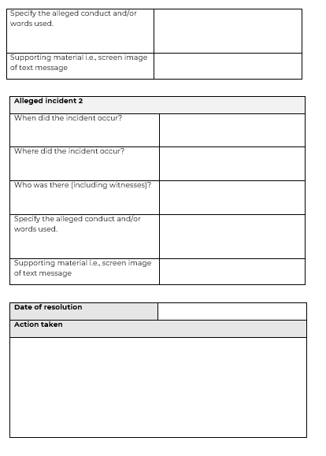
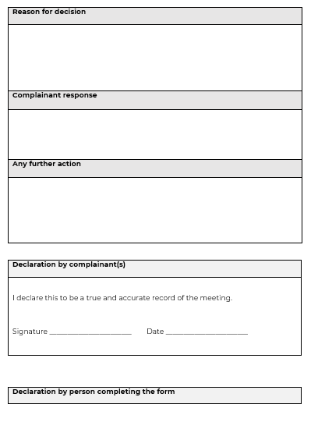 | 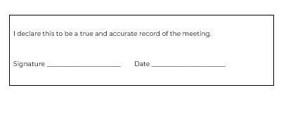

Appendix 2 - Child Safe Reporting Poster

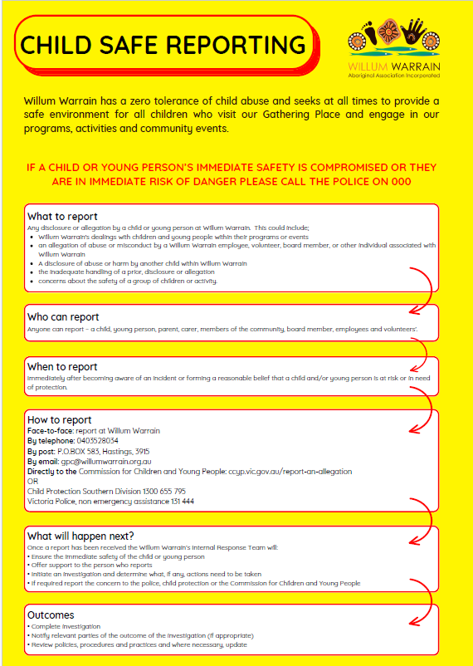

The child safe standards aim to protect children from abuse in organisations, including physical violence, sexual offences, serious emotional or psychological abuse and serious neglect. For further explanation of the different types of child abuse, please see An Overview of the Victorian child safe standards: <www.dhs.vic.gov.au/__data/assets/word_doc/0005/955598/Child-safe-standards_overview.doc>.
A person will not commit this offence if they have a reasonable excuse for not disclosing the information, including a fear for their safety or where the information has already been disclosed. Further information about the failure to disclose offence is available on the Department of Justice and Regulation website <www.justice.vic.gov.au/home/safer+communities/protecting+children+and+families/failure+to+disclose+offence>.
Further information about the failure to protect offence is available on the Department of Justice and Regulation website <www.justice.vic.gov.au/home/safer+communities/protecting+children+and+families/failure+to+protect+offence>.
Mandatory reporters (doctors, nurses, midwives, teachers (including early childhood teachers), principals and police) must report to child protection if they believe on reasonable grounds that a child is in need of protection from physical injury or sexual abuse. See the Department of Health and Human Services website for information about how to make a report to child protection <www.dhs.vic.gov.au/about-the-department/documents-and-resources/reports-publications/guide-to-making-a-report-to-child-protection-or-child-first>.
For example behaviour, please see An Overview of the Victorian child safe standards: <www.dhs.vic.gov.au/__data/assets/word_doc/0005/955598/Child-safe-standards_overview.doc>

